**IT5005 Assignment 1 (Part 1 Task 5 & 6)**

**Task 5 | Online/Instore Movie Ticket Booking Process (BPMN)**

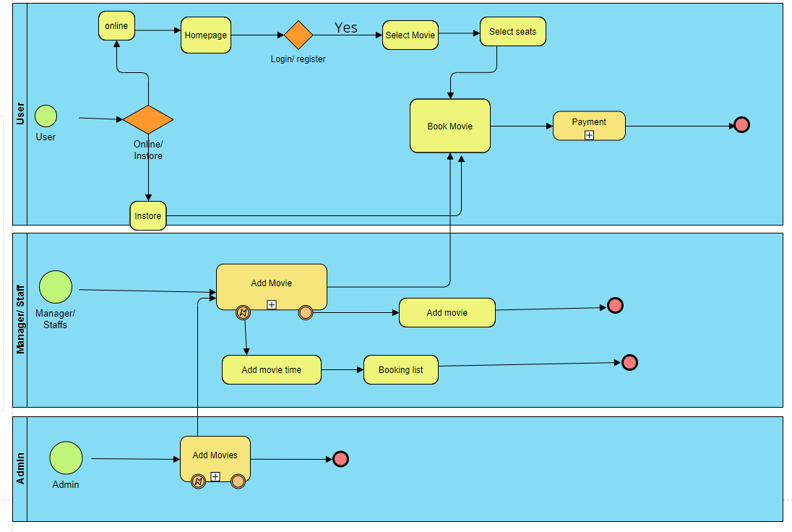

**Brief explanation of the diagram**

**User Pool**

1. Task 1, represent the decision point where the customer can choose online and in-store ticket purchasing. Depending on the customer’s choice, Tasks 2 and 3 represent the different paths that are taken online and ins-store ticket purchasing respectively. Finally, the process ends with an end event.

2. Depending on the decision, Task 2 (online ticket sales) or Task 3 (instore ticket sales) is executed. Task 2 and 3 involves activities such as:

* Customer visit Homepage (online)
* Login or register.
* Customers select movie.
* Customers select seat.
* Customers pay for the tickets.
* System generates electronic tickets.

**Manager and Staffs Pool**

1. Manager and Staff decides whether to open a new movie showtime or not. This decision is based on factors such as availability of staffs, equipment, and movie rights.
2. Depending on the decision, Task 2 (online ticket sales) or Task 3 (instore ticket sales) is executed. Task 2 and task 3, may involve activities such as, adding movie time, adding movie, checking booking list, selecting movie, and showtime, selecting seats and payment processing.

**Admin Pool**

1. Admin manages the movie showtime data (Task 4), including scheduling new showtimes and updating movie information.

**Task 6 | Stakeholder list**

**Internal Stakeholders:**

* Tongariro Cinema Limited (**Primary**)
* Manager and Staff
* Board Members
* Chairman and Secretary
* Admin/Secretary/Finance person

**External Stakeholders**

* Customers (**Secondary**)
* Moriarty Catering Company
* Xero Accounting Software provider

**Potential Stakeholders:**

* Social Media Users